**Operating System**

**Lab No 1**

Ubuntu Installation and Setting up Virtual Machine



**Faculty of Information Technology UCP Lahore Pakistan**

# TOPIC TO BE COVERED

* Introduction to Virtual Box
* Installation of Virtual Box
* Setting up the Virtual Machine
* Installing Ubuntu

# Objectives

* Student get familiar with Virtual box
* Student able to install Ubuntu in its laptop/PC in Virtual Box

# Virtual Box – An Introduction

Virtual Box is a powerful x86 and AMD64/Intel64 virtualization product for enterprise as well as home use. Not only is Virtual Box an extremely feature rich, high performance product for enterprise customers, it is also the only professional solution that is freely available as Open Source Software under the terms of the GNU General Public License (GPL) version 2.

When we describe Virtual Box as a "virtualization" product, we refer to "full virtualization", that is, the particular kind of virtualization that allows an unmodified operating system with all of its installed software to run in a special environment, on top of your existing operating system. This environment, called a "virtual machine", is created by the virtualization software by intercepting access to certain hardware components and certain features. The physical computer is then usually called the "host", while the virtual machine is often called a "guest". Most of the guest code runs unmodified, directly on the host computer, and the guest operating system "thinks" it's running on real machine. Learn more at <https://www.virtualbox.org/>

Now we will start Installing Virtual Box in Windows, to install Ubuntu as virtual machine

# Installing Virtual Box

## You can download Virtual Box from following link.

[VirtualBox Download](https://www.virtualbox.org/wiki/Downloads)

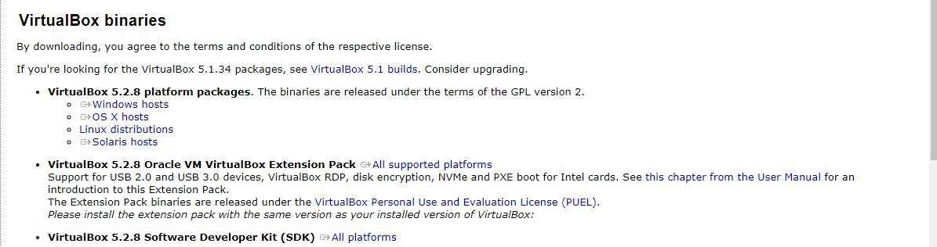

## Click on Windows hosts. After completing the download click on .exe for starting the installation.

**Step1**: Following Welcome screen will appear.

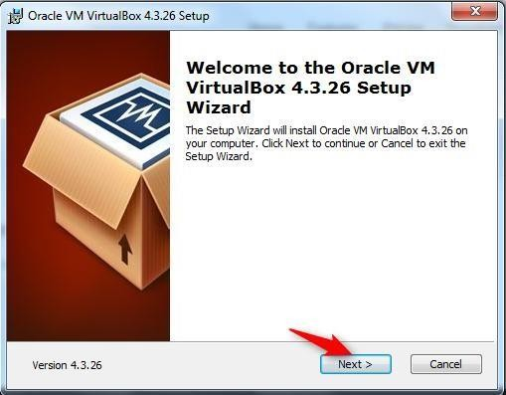

Click “Next” button.

**Step2:** Click Next

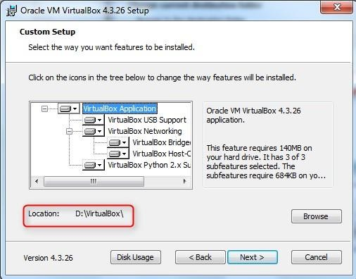

**Step3**: Custom Setup for different features Window is displayed. No need to change anything, just

press “Next” button.

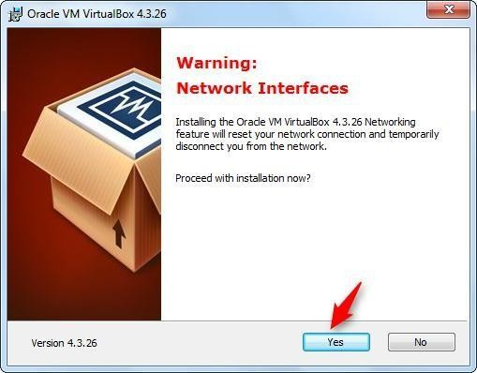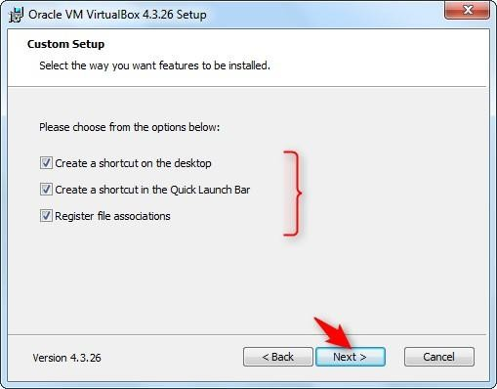**Step 4:** Warning window is displayed. Click Yes.

**Step5**: “Ready to Install” window is displayed. Press “Install” button.

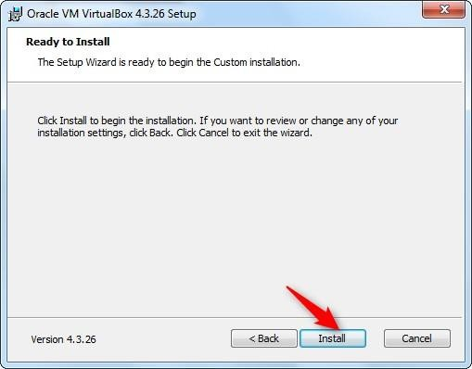

**Step6:** Finally after setup, installation will start and following window will be displayed with status bar.

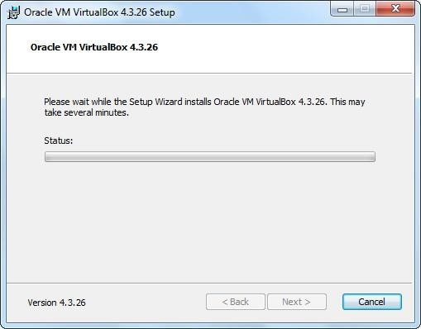

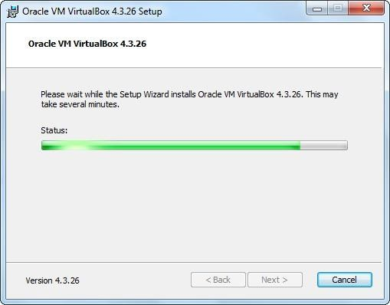Installation continues…

Meanwhile Windows Security will ask for the confirmation of installing hardware. e.g below.

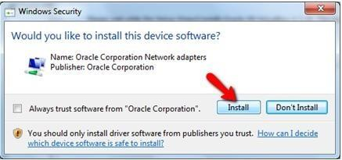

Press Install.

**Step7:** Installation Complete. Press “Finish” button.

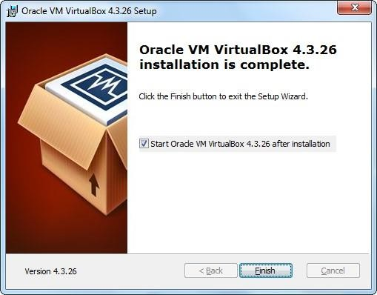

After installation completed, you can find its icon on desktop.

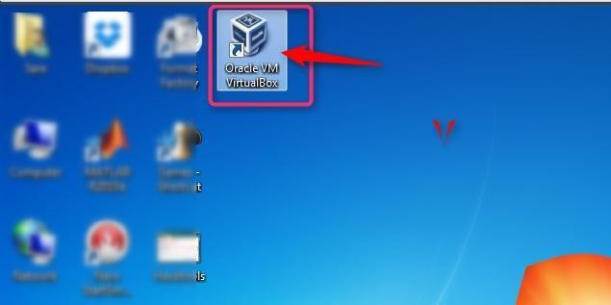

# Setting up Virtual Machine

**Step1:** Click the Virtual Box icon and following window will be opened.

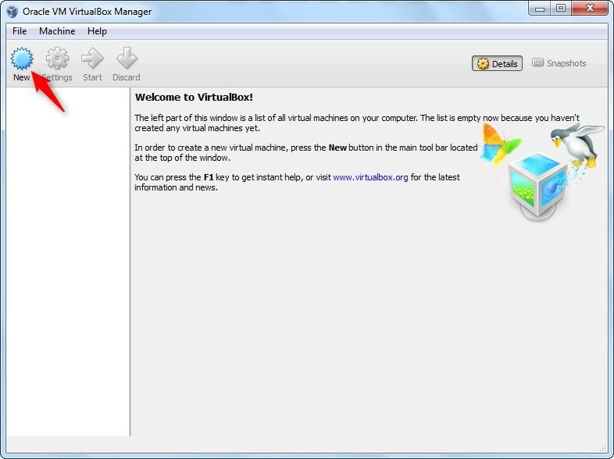

Click on “New” button on top of menu bar.

**Step2**: Step1 will lead you to setup a new virtual machine.

Following window will be opened to setup virtual machine name and type. Press Next.

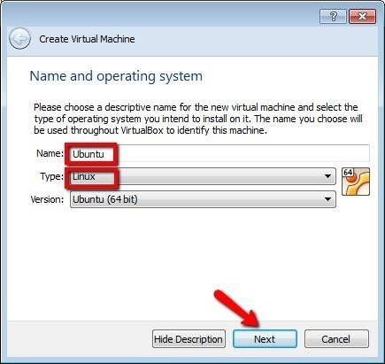

**Step3:** By pressing “Next”, following window will be opened to setup memory size. Minimum size

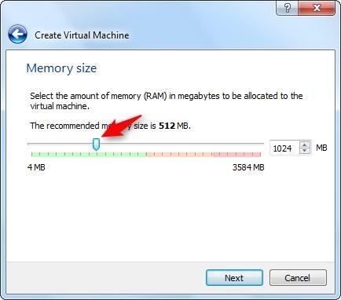

is 1024MB

Press Next.

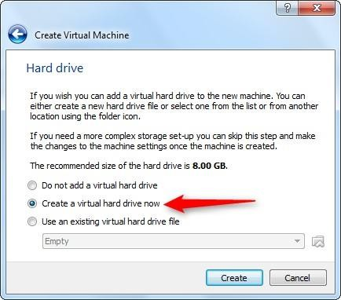**Step4:** By pressing “Next”, “Hard drive” window will be opened. Select “Create a virtual hard drive now”.

Press “Create” button.

**Step 5:** By default, VDI option is selected. Do not make any change and just press “Next”.

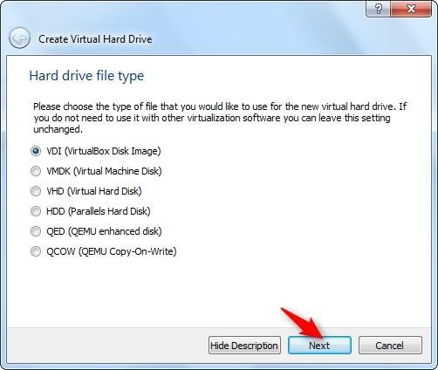

**Step6:** Select “Dynamically allocated”.

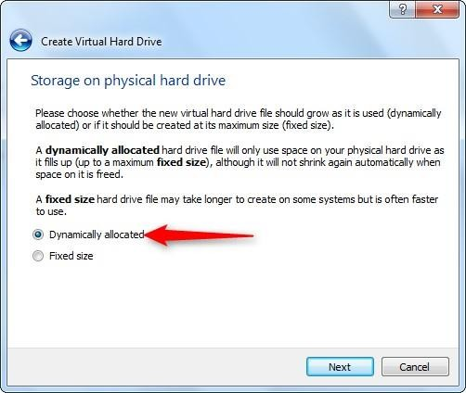

**Step7:** Following window will be opened to setup virtual hard drive size. Here 15 GB is selected but you must select it greater than 100GB if free space is available.

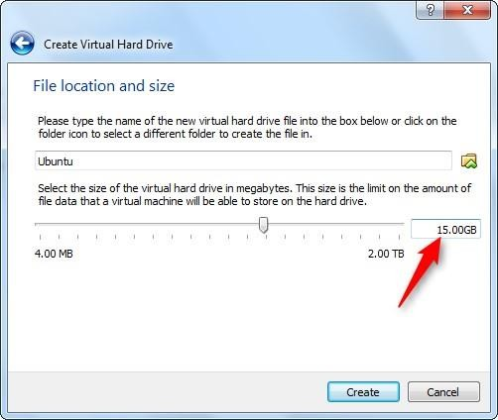

Press “Create” button.

**Step8:** Following window will appear with one virtual machine named “Ubuntu” will be added in left

panel. Click on “Start” button highlighted.

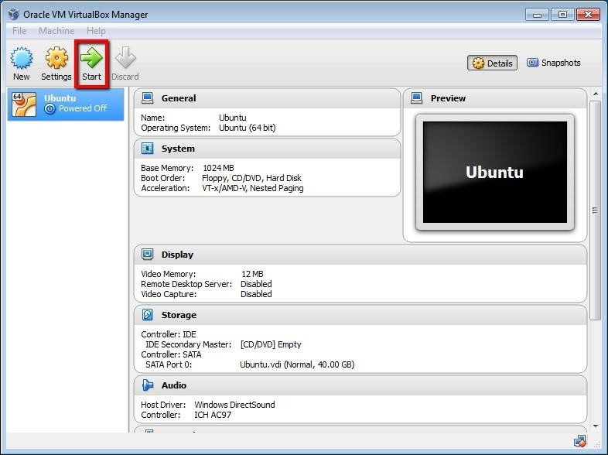

**Step9:** In order to attach ISO image with this virtual machine.

* 1. Click on “Settings” button. Following settings window will open.
  2. Go to Storage Option. Under “Storage Tree” go to Controller: IDE.
  3. Select “Empty” option. By selecting “Empty” Attributes will be changed.
  4. Click on CD icon pointed by arrow in below image.

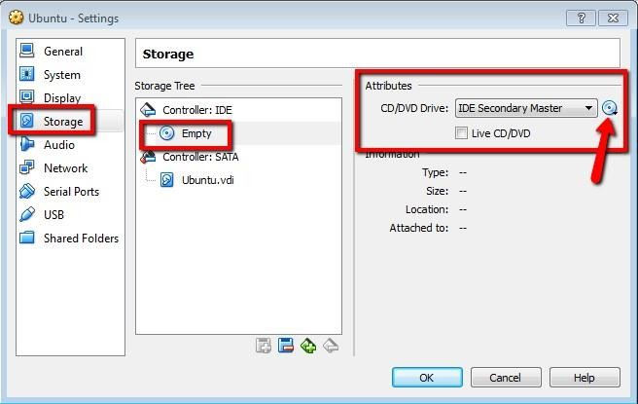

* 1. By clicking at icon of CD, following menu will be displayed.

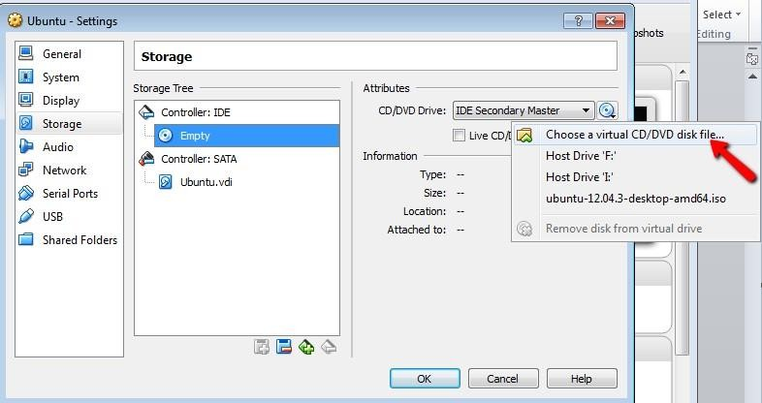

* 1. By clicking on “Choose a virtual CD/DVD disk file… An “Open Window” will appear.

Select .iso(Downloaded From Ubuntu website) image and click “Open” button.

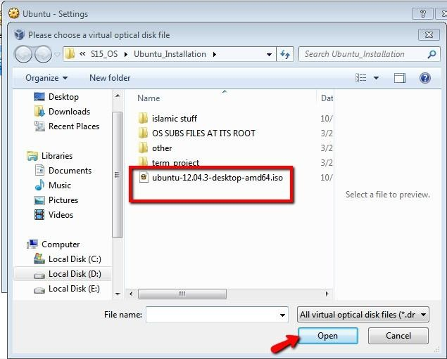

* 1. Now it’s added here. Press “OK” button.

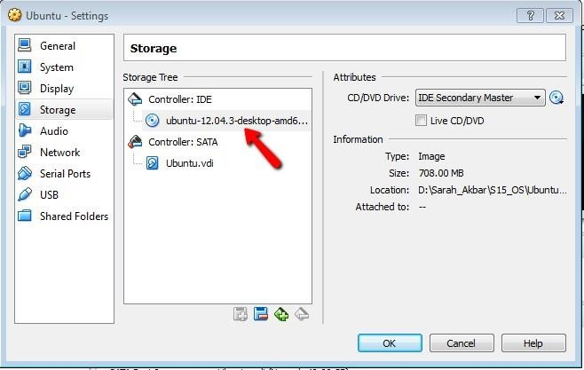

**Step 10:** Click “Start” button and following window will appear.

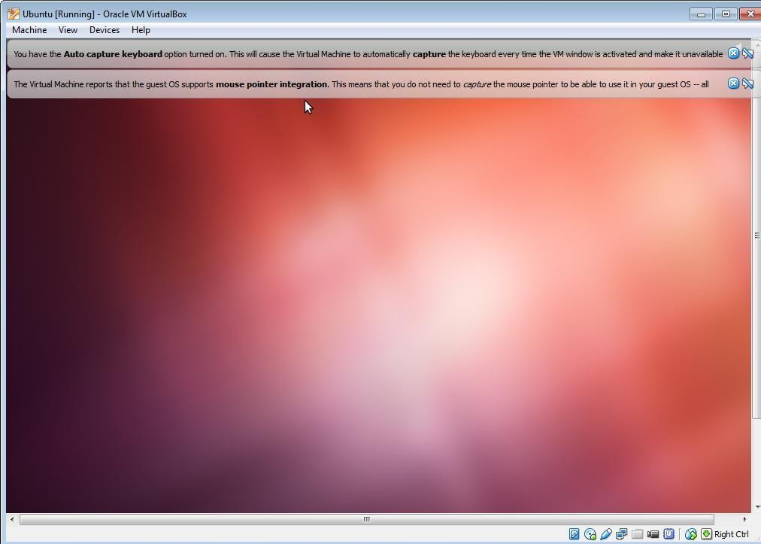

# Installing Ubuntu

**Step1:** Now you will start installing Ubuntu from ISO image just added in virtual machine named

“Ubuntu”

When following screen will appear

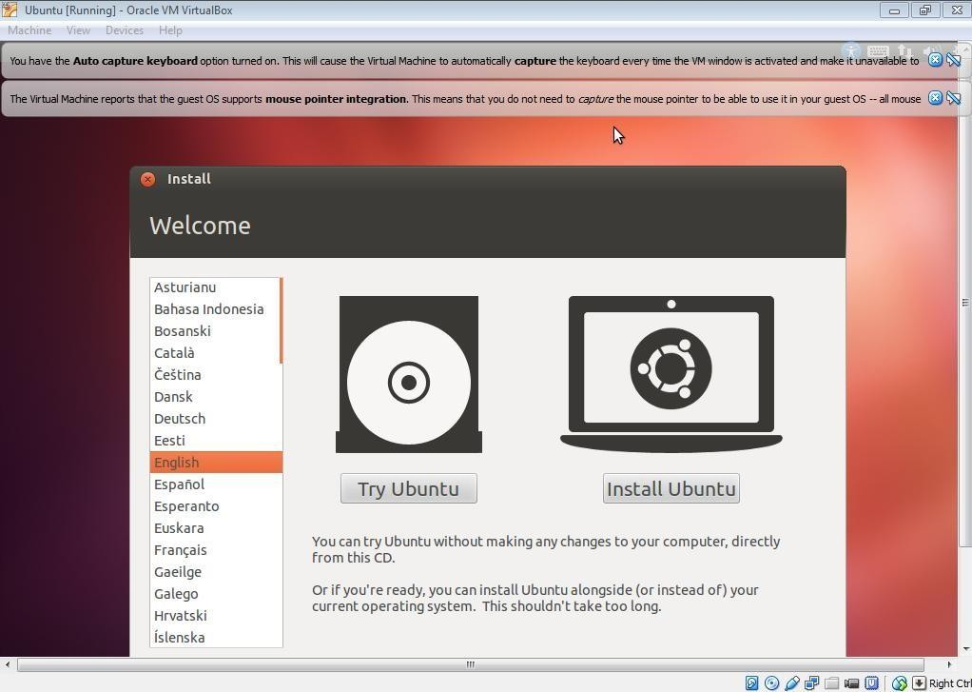**Step2:** Select “Install Ubuntu” button.

**Step3:** Click “Install now”

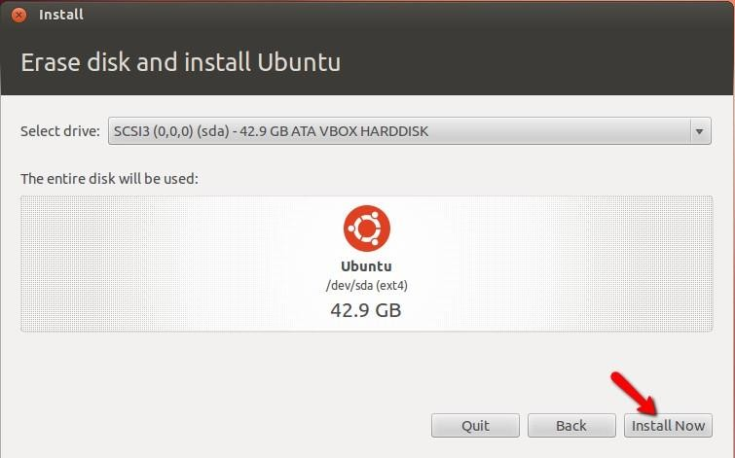

### Step4:

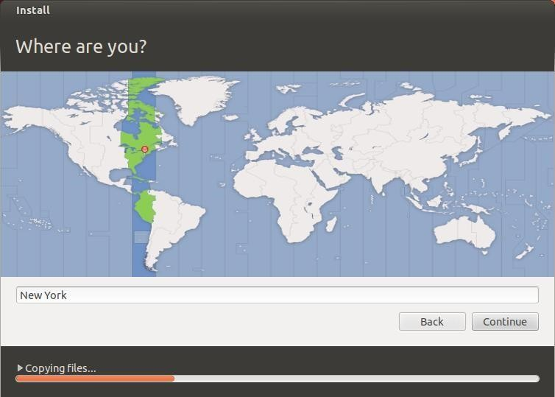

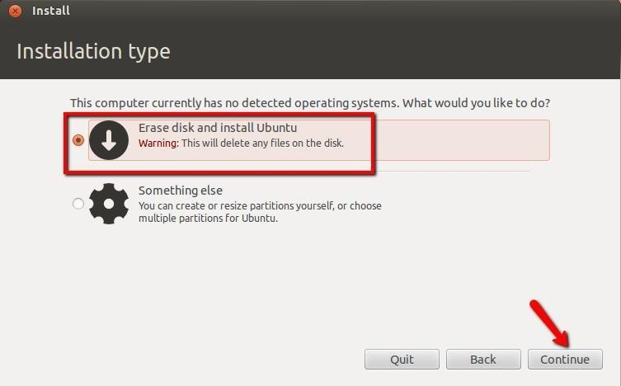

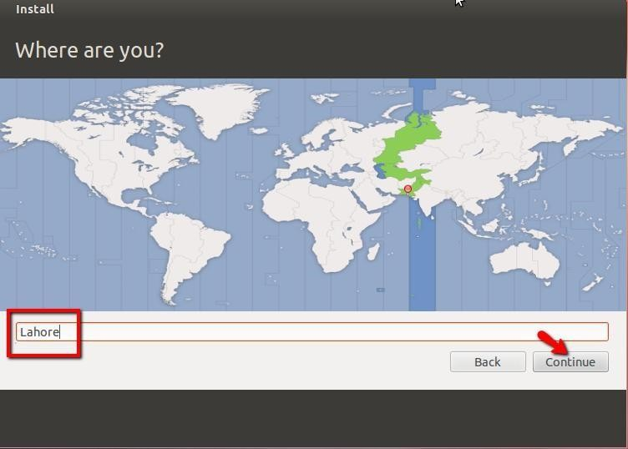

**Step5:** Choose Language

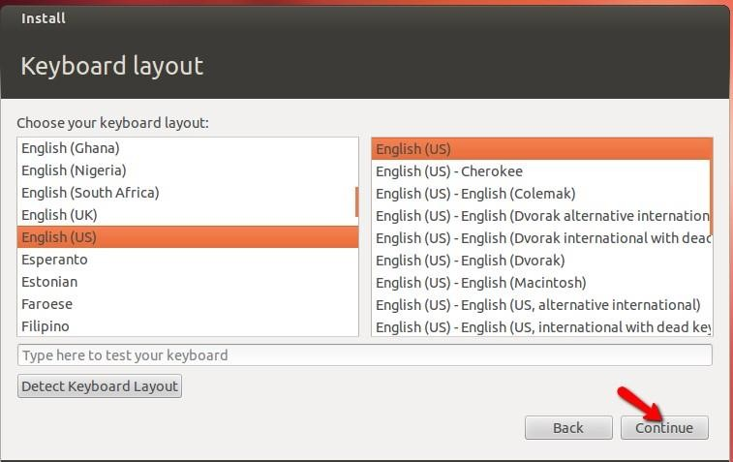

**Step6:** Give username and password information.

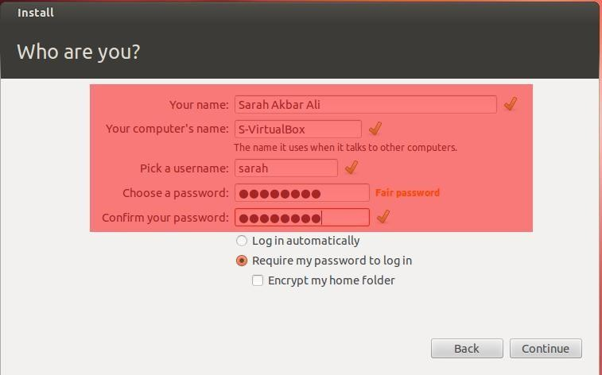

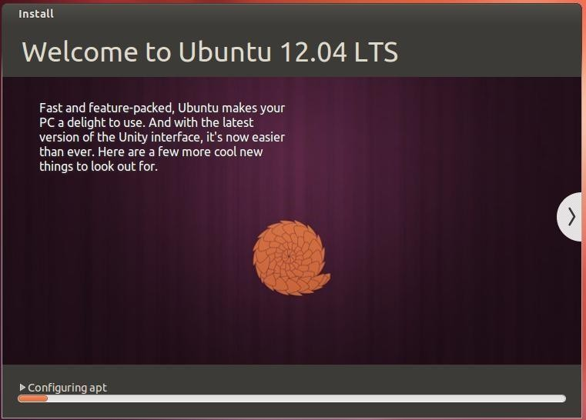**Step7:** Following welcome window will appear

**Step8:** Restart system.

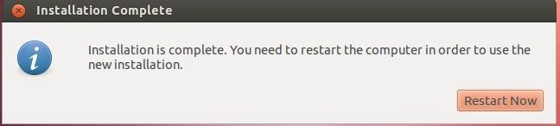

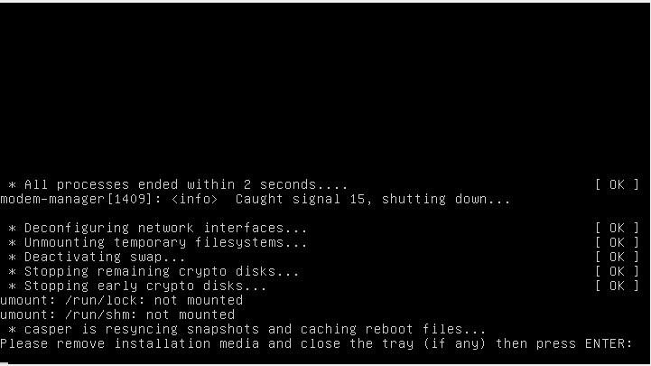

**Step 9:** Press “Enter”. Login into Ubuntu

**Step10**: Desktop of Ubuntu displayed.

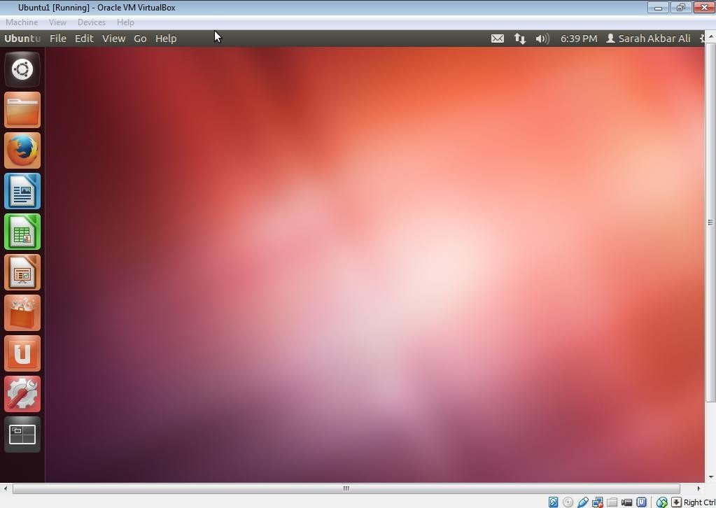

**Step11:** After Installation completed, go to settings and delete Storage link to iso image.



